**1 introduction**

* 1. **Background**

Lewis Mumford, a famous sociologist and literary critic, once said in a metaphorical manner, “[Adding highway lanes to deal with traffic congestion is like loosening your belt to cure obesity.](http://www.azquotes.com/quote/1024074?ref=traffic-congestion)” Fortunately, he did not experience the worse congestion around today’s highway toll plaza.

Each toll plaza has a unique design. Typically, the design is a product of the method of operation, physical constraints, and traffic demands of the facility

Currently, with roaring number of vehicles, rising construction costs and constrained available areas, traffic jam becomes more and more serious but future toll-plaza construction opportunities are limited to improve this situation markedly. Figure 1 shows the congestion in the toll plaza near Tappan Zee Bridge.

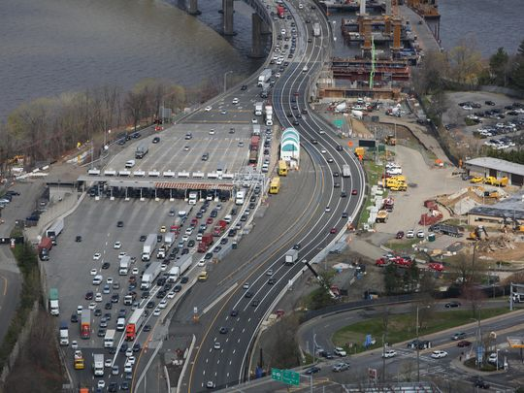Figure 1

Subject to the constraints referred above, neither increasing highway lanes nor building more tollbooths seems practical enough to relieve traffic jam around a toll plaza nowadays, particularly for some heavily-traveled roads such as the Garden State Parkway, New Jersey. Therefore, looking for some innovative design improvements on the geometric parameters of the extent toll plaza seems effective.

* 1. **Restatement of the Problem**

In this paper, we are required to explore if there are better solutions to design a departure zone of a toll plaza. From our perspective, there are at least two steps to determine whether better solutions exist:

Step 1: whether make improvement on departure is urgent and functional

Step 2: If the result of step1 is YES, （后面的相应要改）

In this model, the prerequisite is that vehicles fan in from B tollbooth egress lanes down to L (B > L) lanes of traffic (i.e., the number of both tollbooths and the lanes after merging are fixed). We aim to construct a model that can optimize the arrangement according to the following conditions.

·Enhance the capability of the accident prevention(A).

·Maximize the throughput(T).

·Minimize the cost of the land and road construction(C).

Through our analysis, we determine if there are better solutions than any toll plaza in common use. Afterwards, the performance of our solution in light and heavy traffic and other various situations along with corresponding sensitivity analysis is discussed.

1. **Notations**
2. **General Assumptions**

* **We only discuss “barrier tolls” in our whole paper.** As problem requests, ramp tolls are not included in our discussion.
* We only consider small motor vehicles
* **Vehicles within our consideration have the same size, namely the length as well as the same driving performance.**
* **All the tollbooths are conventional (human-staffed)**

**4 Model 1: The Traffic Throughput Model**

**4.1 Overview**

We manage to design two sub-models to analyze and calculate the maximum throughput in three parts (i.e., the approach zone, the tollbooth area, and the departure zone) of the toll plaza. And we define the throughput of different parts as Q1max and Q2max together, Q3max respectively. Q1max and Q2max can be viewed as the properties of upstream, while Q3max is for downstream. Notice that Q1max, Q2max and Q3max are independent of one another. For example, the fluctuation of the speed when entering the approach zone, which contributes to Q1max, does not influence the average serving time of each tollbooth, which reflects Q2max, and vice versa. In view of the Buckets Effect, the overall the maximal traffic flow Qmax is determined by the minimum among the three values, that is:

Qmax = min{ Q1max, Q2max, Q3max}

Figure 2 illustrates the schematic diagram of the whole.

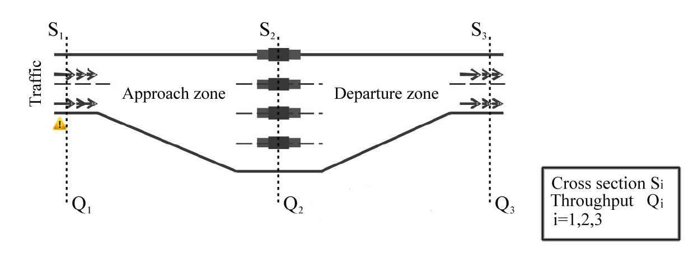

Figure 2

We need to further explain that Qi is the number of vehicles passing through the cross-section Si within a certain time, where i = 1,2,3. Because our main subject is Q3max, which relates directly to subsequent analysis of the shape, size and merging pattern of the departure zone, sub-model 2(the downstream flow model) is more complicated than the former. Relatively simple as sub-model 1(the upstream flow model) is, it still acts as an indispensable reference to help define whether exploring parameters of departure area is meaningful or not.

**4.2 Sub-model 1: The Upstream Flow Model**

In this sub-model, we discuss the maximal approach zone flow Q1max and the maximal tollbooth flow Q2max independently at first. But we need to stress that sub-model 1 primarily serves as a significant reference. Specifically, if either of Q1max and Q2max is larger than Q3max, departure zone will get congested at first as the traffic becomes heavy. Thus, figuring out optimal geometric parameters of departure area is meaningful. Otherwise, it is approach area get stuck at first. Hence, solving the conflict of approach zone seems more urgent, which means the requirement of Problem B is we then deduct a synthetical conclusion in the form of “the maximum upstream flow” based on both results. Thus, we can carry out a convenient analysis in the next step.

**4.2.1 Approach Zone Flow**

In this part, we aim to simulate the maximum flow, Q1max, in the approach zone. However, uncertainties lie in the disparate velocities, distinct driving routes and various situation ahead when different vehicles enter the approach zone. As a result, adequate assumptions are supposed to be offered here so that we are able to formulize Q1max smoothly. Assumptions are listed as follows:

* We only consider small motor vehicles that come across S1.
* Ve**hicles within our consideration have the same performance as well as the same size, namely the length.**
* **The time we are using for the flow calculation is not long**, so that unpredictable variation is not supposed to happen.
* **Vehicles will keep a constant speed within a certain time after crossing S1.** Furthermore, we think that vehicles will travel at the exact speed of what the speed limit sign indicates. It makes sense because each vehicle is compulsory to decelerate below or equal to the restricted speed for the sake of safety. So we can take the restricted speed (a critical value) as the constant speed.
* **Vehicles will move in a straight line within a certain time after crossing S1.** In other words, vehicles do not tend to change lanes in a short period.

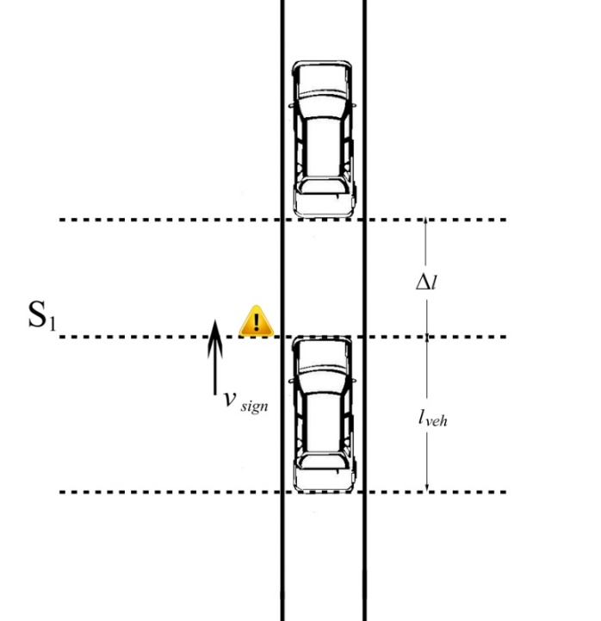Based on these assumptions, we prepare a simplified graph to describe our following work. Details are shown in Figure 3.

Figure 3

Variables in Figure 3 need to be specified:

* S1 is the cross section for flow calculation.
* V_sign means a restricted speed. Each vehicle is compelled to decelerate below or equal to this value. And the yellow triangle in Figure 3 represents a speed limit sign.
* L_veh is the length of a car.
* Deta_l signifies a safe distance between two vehicles averagely. Judged by common sense, it is a function of v_sign, namely, deta_l=f(v_sign)

**Model Establishing**

Formula (1)

Formula (2)

Where，

T the time that a following car consumes to moves to the position of a leading car

L the number of travel lanes

**4.2.2 Tollbooth Flow**

**Assumptions**

·We consider the service time at a tollbooth as the only delay factor for a vehicle.

·The service time for each vehicle at a tollbooth is constant.

**Model Establishing**

In order to obtain the maximal throughput at tollbooths, namely $Q_{2max}$, we consider a simplified case in which vehicles only spend time receiving service at tollbooths. In practice, the serving time of a tollbooth varies a lot with the change of traffic characteristics, service conditions and other different elements. The empirical data shows that commonly a conventional (human-staffed) tollbooth with change giving could serve 350 cars per hour while the number could reach 500 without giving change. We use $η$ to describe a general serving ability of each tollbooth in our model, in order to take both cases into account, we choose the average, that is $η$ =425.

So we get the solution as

$$Q_{2max}=ηB$$

Where,

B the number of tollbooths in the whole toll plaza.

So, Q1max can also be interpreted as the maximal vehicle flow under the “ideal conditions” above.

The first model is determined to simulate the maximum flow Q1 in the approach, which is also interpreted as the vehicle flow under the “optimal occupancy” of the approach zone. The “optimal occupancy” is set to describe a critical ratio of real-time cars amount to the maximum capacity in the approach zone. If the real-time radio is higher than the critical value, the upstream tends to congest gradually next time. While lower, the situation is defined as a smooth or normal one. In other words,